**G.Harish**

**192011095**

**26. Junit Testing to Check whether the given string is printed or not**

**AIM**

To Use Junit Testing Check whether the given string is printed or not.

**PROGRAM**

**package** sse;

**public** **class** junit1 {

**public** **static** **void** main(String[] args) {

// **TODO** Auto-generated method stub

System.***out***.println("hai");

}

}

**OUTPUT**

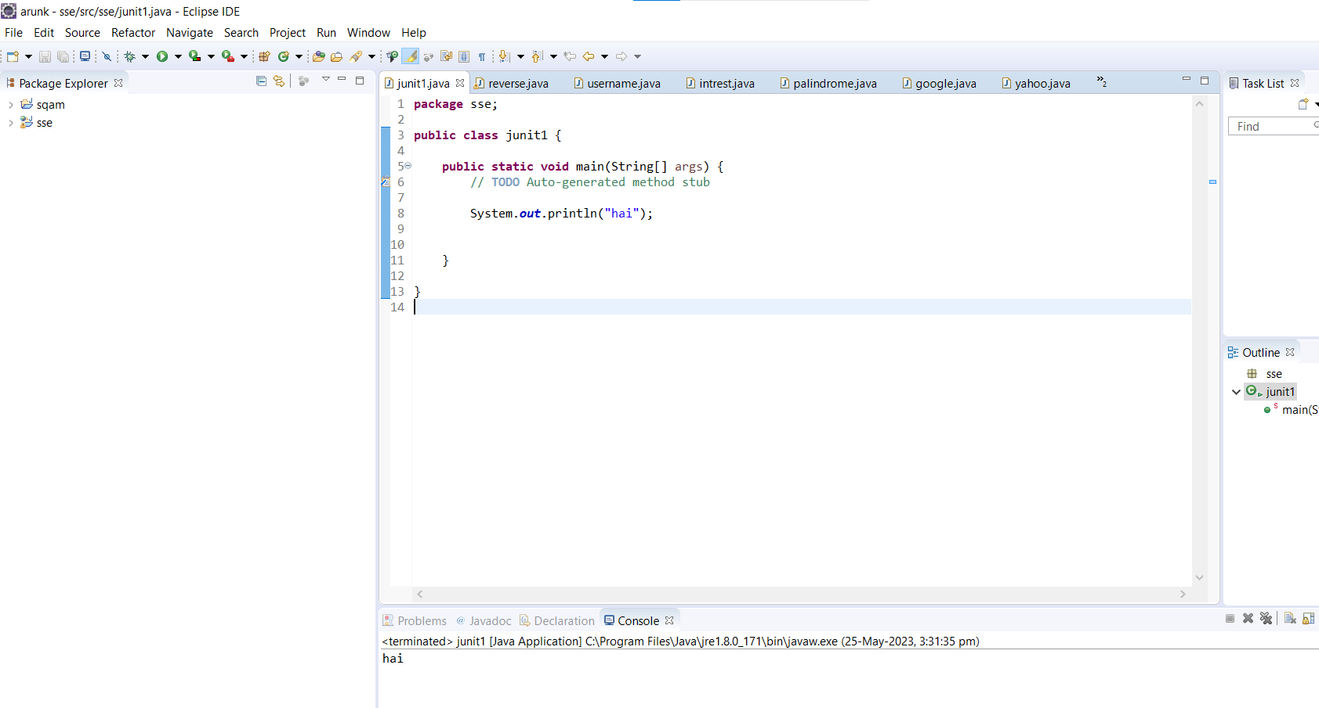

**RESULT**

Hence the Junit Testing to Check whether the given string is printed or not is performed successfully.